**XL Release**

**Release Planning and Management:**

Manage Release using XL Release to monitor your entire release pipeline to get a clear view and up-to-date status information across tools and systems, from code to production.

Reporting and data analytics capabilities that let you make data-driven decisions. Metrics that highlight process bottlenecks so you can optimize.

* Free you from the pain of releases managed by spread sheets
* Document your current release process
* Easily identify aspects of your release process that require improvement
* Stop managing release checklists and start managing the holistic release process

**Steps:**

Design Templates🡪Add Phases🡪Add Task🡪Set Configurations (Manual or Automated)

Set Triggers🡪Parameters-🡪New Release-🡪Start the Release

Report & Metrics🡪Dashboards🡪Analytics

**Release Pipeline Orchestration:**

XL Release is E2E pipeline Orchestration that helps to manage control, visualize the software release process.

Provisioning🡪Building-🡪Deployment🡪Testing🡪Operate

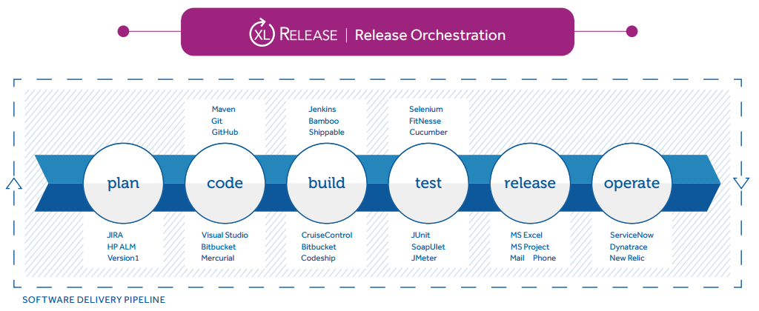

* Automation of software release pipelines, including dependency management
* Ability to orchestrate both manual and automated tasks
* A tool that is easy to use for both business and technical users, with no need for special skills
* Status dashboards, reporting, release metrics and analytics that offer clear visibility into release progress, failures and bottlenecks, and that provide the insights needed for continuous improvement
* Ready-to-go plugins to orchestrate existing tools in the pipeline, like Jenkins, GitHub, JIRA, Ansible, Chef, Puppet, and ServiceNow
* Enterprise controls that automatically enforce compliance, security and quality requirements across the software delivery pipeline

**XL Release Vs Jenkins:** More Notes in below link

XL Release First:

Jenkins First:

Hybrid Pipeline:

<https://blog.xebialabs.com/2014/05/18/three-ways-using-xl-release-jenkins-continuous-delivery-part-2/>

**XL Deploy**

[XL Deploy](https://xebialabs.com/products/xl-deploy/) is the only application release automation solution that is agentless across all target platforms. Connect to Windows and UNIX target systems using proven, industry-standard remote protocols; no agent installation and maintenance, no overhead on the target systems, no firewall ports to be opened, and no security reviews.

* Agentless architecture
* Model-based, highly scalable approach
* Visual status dashboards
* Deployment analytics and reports
* Enterprise security and centralized audit capabilities
* Easy to adopt, easy to use
* Automated Rollback
* Jenkins plugin to automate deployments to all environments

**Unique Features:**

* Generates Deployment plan
* Orchestration
* Parallel deployments
* Usage of dictionaries (centralized location to maintain configurations)
* Roll back plans
* Dependency Management
* Not a workflow based engine or scripts involved